**CS 1632-Deliverable 5**

David Sweeney

<https://github.com/dms163/SlowLifeGUI>

For this deliverable I profiled the program using Java VisualVM. Within the Java VisualVM I utilized the sampler tool. I ran an instance of the game and started the sampler. The sampler than pointed me to a two methods with very large cpu consumption. These methods were the convertToInt and runContinuous in the MainPanel.java file. The sampler also pointed me to the Cell.java file but with no specific method. This prompted me to look through each method to discover any code that would impact the runtime in a strong manner. I found a for loop within the toString method that pointlessly and needlessly went to ten thousand. I commented out the for loop to improve performance of the toString method. The convertToInt function had a bunch of code that was totally pointless. The method convertToInt takes an int and is supposed to return an int so the method can just return the argument. Finally, runContinous had a for loop within a try statement that again was just a performance hit and wasn’t vital to the method so I commented out the loop.

Before screenshot:

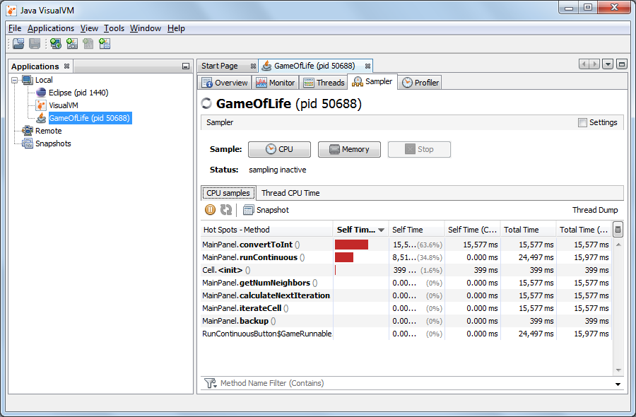

After screenshot:

